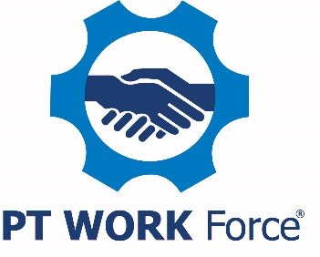

Sample Job Posting Template

Job Title: Human Resources Manager/Director

About Us [or What Makes Our Company Special]
Include all the cool things about your company and what makes your firm special. As an example:

PTDA Bearings & Power Transmission, Inc. is a small family business that believes our employees are part of the family and our company is part of the community. From our central location for the past 84 years, you may have seen us pitch in at the local food bank, sponsor a Little League team and hold a holiday open house for the community.

Our Values
Explain how the position fits in the company and why it is important. As an example:

Our mission is to keep our customers, our suppliers and our employees saying good things about how they were treated.

Explain why this position is important to your company:

The human resources manager must be able to understand the company’s business goals and anticipate the talent needs required to meet those goals. The human resources manager is also responsible for strategy development to leverage best-in-class integrated talent management performance and career development methods to address the talent needs across the company. This position is critical to the company’s growth.

The Job
List three-five tasks the person is responsible for. Use an active voice.

The human resources manager is a key player in the company’s growth. Company leaders will partner with the manager to develop human capital goals that will enable the company to achieve its goals.
- Participates actively in developing the organization structure and culture.
- Coaches and supports company leaders to drive efficiency and effectiveness by proactively managing their direct reports.
- Implements human resource strategies by establishing departmental accountabilities, meets company’s training and development needs, establishing succession planning and labor relations.
The Ideal Candidate
Describe the kind of person who would be a perfect fit for the job.

The ideal candidate for this critical position is comfortable interacting with executives and able to effectively communicate talent needs. This individual has at least five years of experience in managing a human resources department, a bachelor’s degree in human resources and a proven knowledge of a broad range of human resource functions, including employee relations, performance management, talent acquisition and development and organizational design.

Our Offer
What’s in it for them (besides the job)? For this level of position, benefits such as retirement planning, paid health insurance and paid time off as well as a flexible work schedule are important. Remember to include benefits, especially any that you believe are unique to your company. Potential candidates are interested in salary/pay rate. You may want to consider including to help weed out those not willing to work for what you’re offering.

We offer a competitive salary and benefits package and provide 25 paid days off a year at this level. We also provide health and dental insurance for you and your dependents as well as a 401(k) with employer match up to four percent. There is an opportunity for a remote/hybrid work arrangement.

Include any other additional information that would help a candidate learn more about your company. As an example:

To learn more about us, watch our video at youtube.com/PTDABearings.

Close with letting the candidates know how to communicate with you. It is essential that you offer an electronic way for them to apply.

Let us know you’re interested! Click on the link below to apply or email your resume to HR@PTDABearings.com.

